Information Technology: PAT



Caleb Eloff
Grade 12WL
Protea Heights Academy
Table of Contents

Task Definition (Task 1A) 1
User Requirements (Task 1B 3
Database Design (Task 2) 5
Database Relationships 5
Data Dictionary (Task 3A & Task 3B & 3C) 6
Classes and Objects 6
Text File 8
Array 10

Navigation Flow Diagram (Task 4A) 11
GUI Design (Task 4B) 12
Input, Processing, Output (Task 5) 15
Input 15
Processing 17
Output 20

Task Definition (Task 1A)
1. TOPIC
Travel is one of the most exciting parts of modern life, yet booking flights can often be stressful, confusing, and time-consuming. Many people struggle with comparing options, managing bookings, and keeping track of important details such as destinations, dates, and costs. Without a proper system, mistakes are common and customers often feel frustrated. This is where the A-Way Flight Booking System comes in.
2. PURPOSE OF PROGRAM
This application aims to simplify the flight booking process by providing users with an easy-to-use platform where they can register, log in, and securely manage their travel plans. By combining convenience with structure, the program ensures that both passengers and administrators can work more efficiently. Passengers will be able to book flights, view their reservations, and update their personal information, while administrators will be able to oversee accounts and manage bookings in the background.
3. POSSIBLE SOLUTION
The solution is a Delphi-based offline application that uses a database to store user accounts and text files to record booking information. The program includes a login and registration screen for account access, a booking screen to search and reserve flights, and a personal profile screen where users can view their existing bookings. An additional admin screen also allows for flight and account management.
4. SCOPE
The scope of the project is limited to functioning as a local booking manager. It does not connect to real airline databases or process online payments. Instead, it demonstrates the core concepts of data storage, user management, and booking functionality, making the system both practical and reliable for its intended purpose.

User Requirements (Task 1B)

User Type | Role | Activity | Limitations
Passenger (Client)– standard users who want to book and manage flights. | To create an account, log in to said account, book flights, and manage their own bookings as well as their account details. | Register a new account. | Cannot view or edit other users’ bookings.
 |  | Log in to their account. | Cannot add or remove flights from the system.
 |  | Search for flights and view available options. | Cannot access administrator tools or manage accounts
 |  | Book flights and reserve seats.
 |  | View their booked flights.
 |  | Update their personal details.
Administrator (Admin)–  advanced users responsible for managing accounts and flight data. | To oversee the system, maintain user accounts, and ensure that flight booking records remain intact and accurate. | Log in with administrator credentials. | Cannot book flights like a passenger.
 |  | Add user accounts. | Cannot make payments through the system.
 |  | Remove user accounts. | Cannot view the personal data of users beyond what is necessary for administration purposes.
 |  | Update user accounts.
 |  | Manipulate flight pricing.
 |  | Manage user’s flight details.

User Stories

- Passenger (Client)
  - As a passenger, I want to create a new account so that I can book flights using my personal profile.
  - As a passenger, I want to log in with my username and password so that I can securely access my account.
  - As a passenger, I want to search for available flights so that I can choose a destination and travel date.
  - As a passenger, I want to book a flight and reserve seats so that I can confirm my travel plans.
  - As a passenger, I want to view booked flights so that I can keep track of my reservations.
  - As a passenger, I want to edit my personal details in my profile so that my account information stays up to date.

- Administrator (Admin)
  - As an administrator, I want to log in with my admin credentials so that I can access the administrative features of the system.
  - As an administrator, I want to add, update, or delete user accounts so that I can manage passengers effectively.
  - As an administrator, I want to assist passengers by resetting accounts or correcting booking errors so that users have a smooth experience.
  - As an administrator, I want to adjust booking prices so that the prices can be competitive enough to survive in the business industry.

Database Design (Task 2)

PK = Primary Key
FK = Foreign Key
tblAccounts
FieldName | Data Type | Field Size | Example
UserID (PK) | Short Text | 16 | caleloelo5360
FirstName | Short Text | 30 | Caleb
LastName | Short Text | 30 | Eloff
Email | Short Text | 128 | elocal21@gmail.com
Password | Short Text | 128 | elocal21
Admin | Yes/No | 1 | No

tblFlights
FieldName | Data Type | Field Size | Example
FlightID (PK) | Short Text | 16 | FLAE4427
NOSeats | Number | Integer | 13
DepartureDate | Date/Time | Short Date | 9/1/2025
TotalPrice | Number | Double | 24418.42
UserID (FK) | Short Text | 16 | farashash9992

Database Relationships

Each account will have one or many flights.
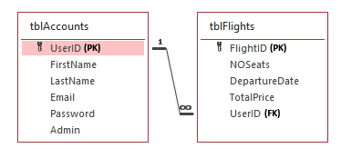

Data Dictionary (Task 3A & Task 3B & Task3C)

Classes and Objects

Account Manager Class:
The account manager class is responsible for handling user authentication and account management functions. It allows for the creation, update, removal, and display of accounts. It also allows for the filtering of flights by users and the maintaining of the UI grid display. This adds value to the system by making the account management, the account’s associated flights as well as the login and registration process more secure and easier to maintain.

TAccountManager
(Attributes)
- sUserID: String;
- The rest is covered by internal methods and references to dmAccounts [Data module containing account and flight tables (tblAccounts and tblFlights)]
(Methods)
+ CreateAccount;
+ UpdateAccount;
+ RemoveAccount;
+ RefreshAccountGrid;
+ RefreshAllTables;
+ FilterFlightsByUserID(sUserID: String);
+ ClearFlightFilter;
+ ResizeGridColumns(Grid: TDBGrid);

Description of Methods
- CreateAccount – Mutator Method
  - Prompts the admin for new user details (first name, last name, email, password, and admin flag). Checks for duplicate emails, generates a unique UserID, and inserts the new account into tblAccounts. Also refreshes the account grid and flight tables.
- UpdateAccount – Mutator Method
  - Allows the admin to edit the details of the currently selected user. Validates input (including email format), updates fields in the database, and refreshes the account grid and tables alike.
- RemoveAccount – Mutator Method
  - Deletes the selected user from tblAccounts along with all their linked flights from tblFlights. Confirms with the admin before deletion.
- RefreshAccountGrid – Accessor Method
  - Reloads qryAccounts and qryFlights queries to reflect changes that occurred in the database and updates the display grids, ensuring that the on-screen grids display the latest information.
- RefreshAllTables – Accessor Method
  - Reloads both tblAccounts and tblFlights tables to reflect any possible changes to ensure the provision of the latest information.
- FilterFlightsByUserID(sUserID: String) – Auxiliary Method
  - Filters flights table to show only flights belonging to the specified user.
- ClearFlightFilter – Auxiliary Method
  - Removes any active flight filters to display all flights.
- ResizeGridColumns(Grid: TDBGrid) – Auxiliary Method
  - Evenly resizes visible columns in the provided grid for better display and alignment.

Profile Manager Class:
The profile manager class is responsible for managing the display and editing of personal account details. It retrieves user information from the database and shows it in a formatted TRichEdit report. Users can then edit their profile, and the class validates all inputs before updating the database. This class adds value by allowing users to maintain their account information safely, ensuring data integrity, while providing an easy way to view and edit their profile details.

TProfileManager
(Attributes)
- sUserID: String;
- sName: String;
- sEmail: String;
- sPassword: String;
- The rest is covered by internal methods and references to dmAccounts [Data module containing account and flight tables (tblAccounts and tblFlights)]
(Methods)
+ LoadProfile(sUserID: String; RichEdit: TRichEdit);
+ EditProfile(sUserID: String; RichEdit: TRichEdit);
- ValidateName(sName: String; sFieldLabel: String): Boolean;
- ValidateEmail(sEmail: String): Boolean;
- ValidatePassword(sPassword: String): Boolean;

Description of Methods
- LoadProfiles – Accessor Method
  - Retrieves the user's profile from the database and displays it in a formatted RichEdit.
- EditProfile – Mutator Method
  - Prompts the user to enter new profile details, validates the input, and updates the database.

- ValidateName – Auxiliary Method
  - Ensures the name is not blank and contains only alphabetic characters.
- ValidateEmail – Auxiliary Method
  - Checks that the email contains an '@' and ends with '.com'.
- ValidatedPassword – Auxiliary Method
  - Ensures the password is not blank or just spaces.

Text File

The first text file is ‘Countries.txt’. It is used to store a list of countries available for selection in the booking interface. This helps to avoid hardcoding country names in the program. The file is read when the program needs to display a dropdown list of countries. The file is not written to.
Example:
- United States
- Canada
- Mexico

The second text file is ‘tempFlights.txt’. It is used as a ‘scratchpad’ in a sense, as it temporarily stores the search results of available flights before final booking. This avoids repeatedly querying the database when a user browses flight options. The file is read when the user searches for available flights, in which this file is read to display options available to the user. After a search is made, the program writes the available flights into this file in the following format: ‘Airline FlightID%PricePerSeat’, which the user can then choose from to be their flight booking.
Example:
- SkyJet FLKQ7565%4931.05
- AirNova FLAS1449%4116.75
- CloudRunner FLLL7935%4840.57

The 3rd text file is ‘<username>_Booking.txt’. It is used to store the flight booking confirmations for each user. This ensures that each booking has a record of extra information outside of the database. It can be used to generate boarding passes, provide receipts or keep logs of flight history. It is read when a user views their booked flights, the program will open the corresponding text file and display their booking details. When a new flight is booked, the text file is created / updated with the new booking details.
Example:
==============================
Booking for: caleloelo5360
FlightID: FLEC6783
From: Canada
To: Colombia
Class: First Class
Seats: 2
Price per seat: R1446.15
Departure Date: 10/9/2025
Booking Date: 8/19/2025
==============================

Array

An array of objects (arrAirplaneNames) is used to store all airplane names that can be used to form part of the ‘tempFlights.txt’ file’s lines when when a user performs a search. The objects in the array are instantiated via a constant containing 30 potential names.
In addition, a one-dimensional array, arrParts, is used to temporarily store flight details that are read from each line in the text file after being split via the % delimiter, resulting in the parts showed in the arrParts (e.g. arrParts[0] = SNAAFL123; arrParts[1] = 4650.20). This array is used to easily separate and access differrent pieces of data from the text file so that they can be displayed in the grid of available flights.
Another one-dimensional array, arrLastDeletedRowData, is used to temporarily store the values from a record that have been deleted in a string grid (e.g., a booking). This allows the program to either restore the deleted row or to keep a record of what was removed. When a user deletes a row, its cell values are copied into the array. If the user cancels or undoes the deletion, the values in the array are written back into the grid. Once deletion is confirmed or undo is no longer possible, the array is reset. This array is useful as it ensures data integrity by keeping track of the last deleted record, preventing accidental loss of information.

Navigation Flow Diagram (Task 4A)
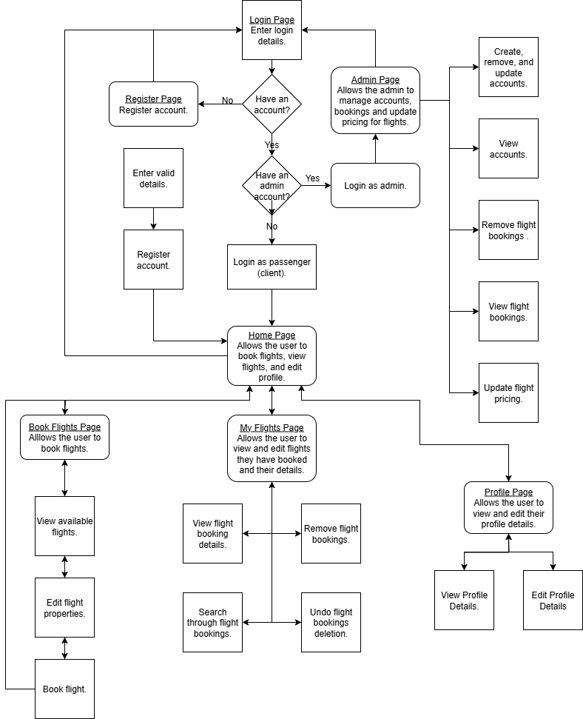

GUI Design (Task 4B)

frmLoginRegister
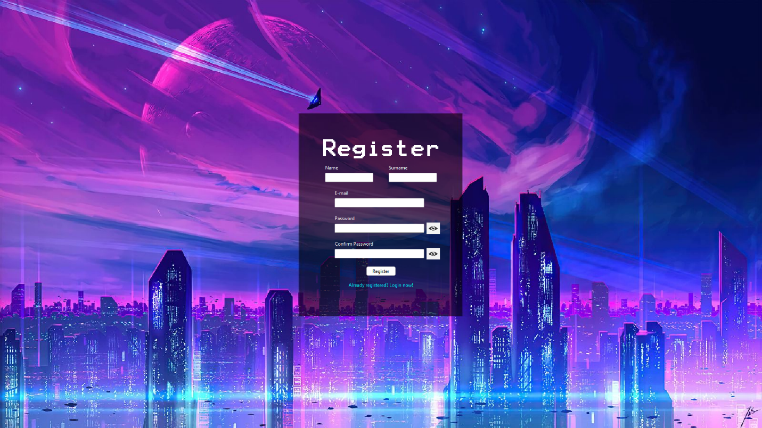


frmHome

frmBookFlights
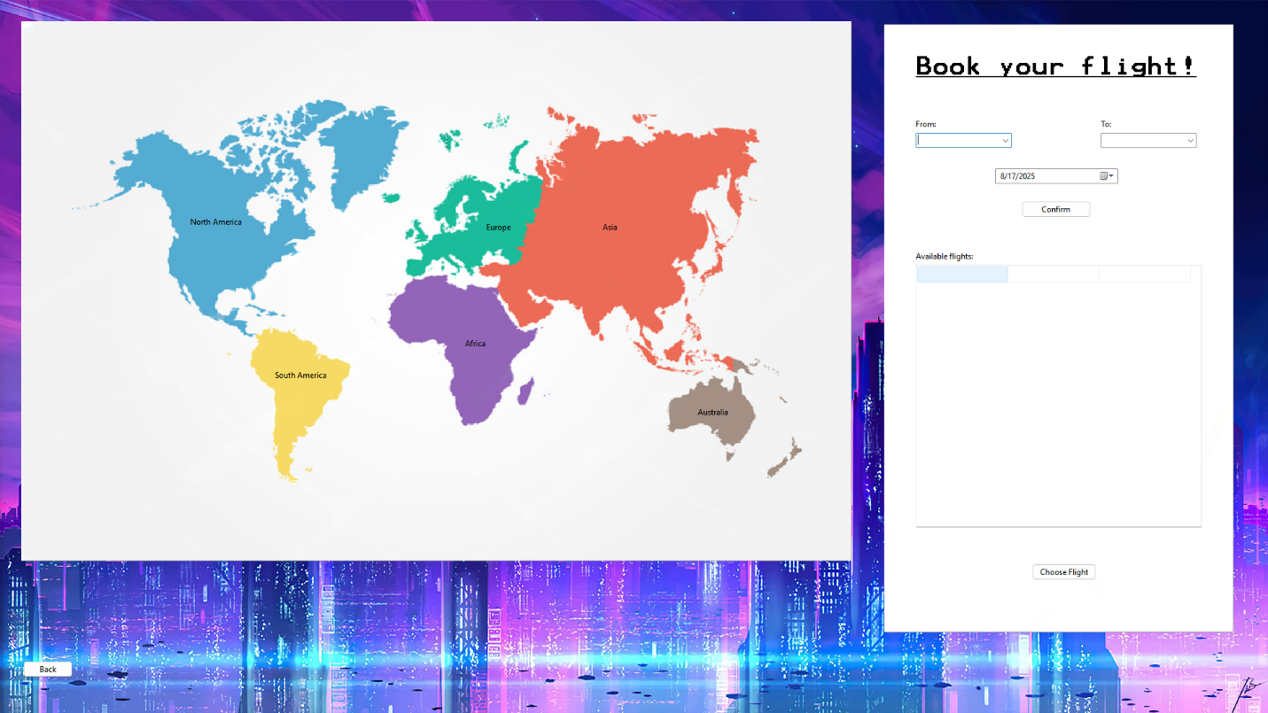

frmMyFlights
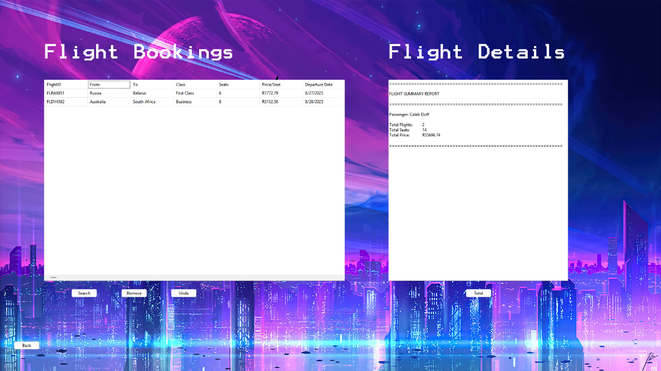

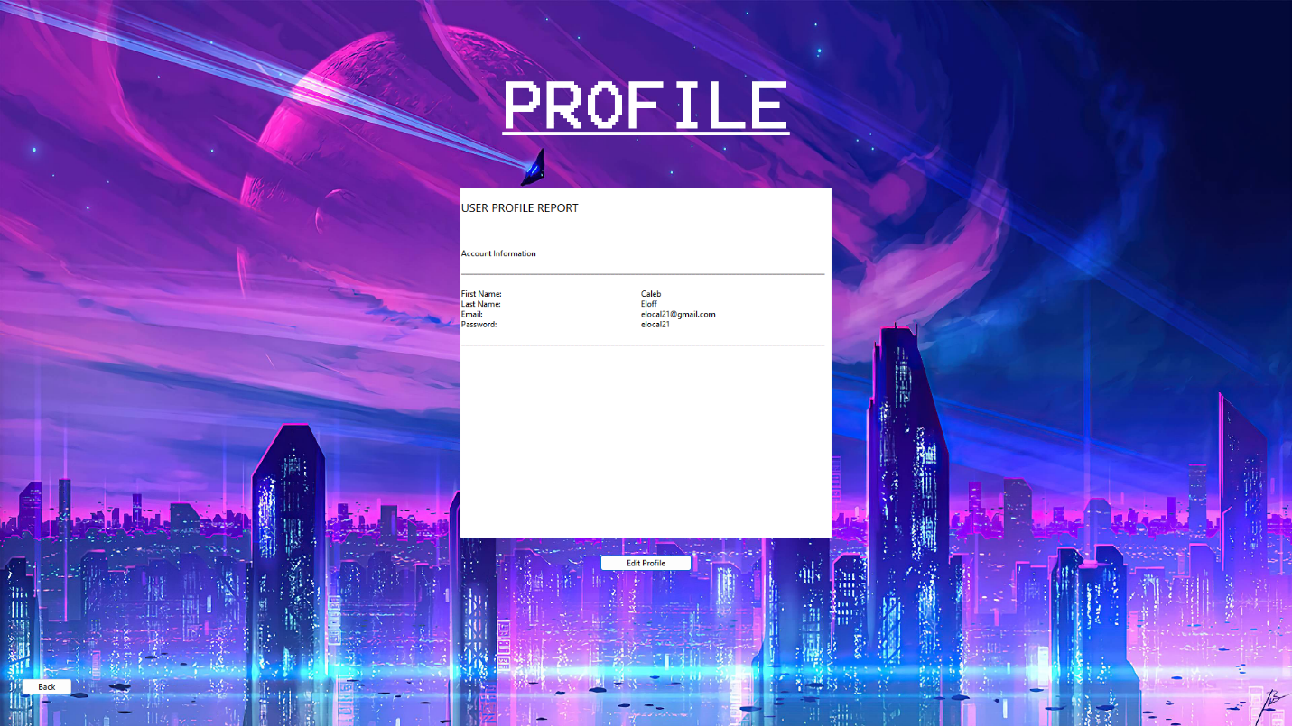
frmProfile

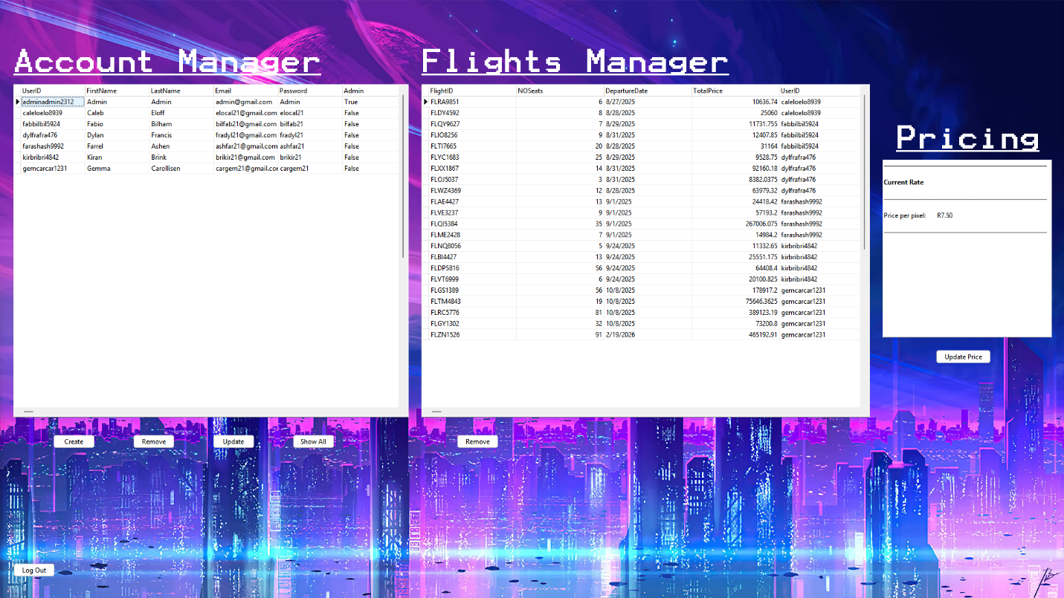
frmAdmin

Input, Processing, Output (Task 5)

Input

Screen 1: frmLoginRegister

Input | Source | Data Type | Format | GUI Component | Validation | Error Message
Login Email | User | String | xxxx@xxxx.com  or  xxxxxx@xxxxx.co.za | edtLoginEmail | Must not be empty; must contain @ and .com (basic check) | “Please enter a valid e-mail.”
Login Password | User | String | Alphanumeric + symbols (! @ # $ % ^ &) | edtLoginPassword | Must not be empty; only valid characters allowed. | "Please enter all your details."  or  "Invalid password."
Register First Name | User | String | Letters only | edtRegisterName | Must not be empty; only alphabetic characters allowed. | “Please enter all your details”.
Register Surname | User | String | Letters only | edtRegisterSurname | Must not be empty; only alphabetic characters allowed. | “Please enter all your details”.
Register Email | User | String | xxxxx@xxxx.com  or xxxxx@xxxx.co.za | edtRegisterEmail | Must not be empty; must contain @ and .com/.co.za. | "Please enter a valid e-mail."
Register Password | User | String | Alphanumeric + symbols (! @ # $ % ^ &) | edtRegisterPassword | Must not be empty; only valid characters allowed. | “Please enter all your details”.
Re-enter Password | User | String | Alphanumeric + symbols (! @ # $ % ^ &) | edtRegisterReEnter | Must match Register Password. | "Passwords do not match."
Duplicate Email Check | Database  (tblAccounts) | Boolean | N/A | btnRegisterClick logic | Checks if Email already exists in database. | "Account already exists."
Login Credentials  Check | Database  (tblAccounts) | Boolean | N/A | btnLoginClick logic | Checks if Email and Password match record. | "E-mail and/or password is incorrect."
Admin Login Check | Database  (tblAccounts) | Boolean | N/A | btnLoginClick logic | If Admin = True, user is logged in as admin. | N/A (Shows "Welcome admin account!").
Form Close | System | N/A | N/A | FormClose event | Terminates entire application when form closed. | N/A.

Screen 2: frmBookFlights
Input | Source | Data Type | Format | GUI Component | Validation | Error Message
Departure Airport | Keyboard  or  Combobox | String | Airport code or name | cmbDeparture | Must not be empty. Must be different from Arrival Airport. | "Please select a valid departure airport."
Arrival Airport | Keyboard  or  Combobox | String | Airport code or name | cmbArrival | Must not be empty. Must be different from Departure Airport. | "Please select a valid arrival airport."
Travel Date | Mouse  or DateTimePicker | Date | dd/mmy/yyyy | dtpTravelDate | Must not be empty. Cannot be before today’s date. | "Please select a valid future date."
Number of Passengers | Keyboard  or  SpinEdit | Integer | Integer | spnPassengers | Must be ≥ 1 and ≤ available seats. | "Enter a valid passenger count."
Class Type | Mouse  or  RadioGroup | String | Economy  or  Business  or  First | rgrpClassType | Must select one option. | "Please select a class type."

Processing:
Process to be done:
- Authenticate a user by validating login credentials against the database.
- Register a new user account by inserting their details into the database.
- Generate a unique UserID when creating a new account.
- Restrict invalid input in text fields using OnKeyPress validation.
- Allow the user to toggle password visibility between masked and unmasked.
- Display available flights by reading from a temporary text file and splitting the data into airline, flight number, and price.
- Calculate the estimated ticket price based on distance between destinations and class type selected.
- Save a booking into the database once all flight and passenger details are validated.
- Search and display all bookings belonging to the currently logged-in user.
- Cancel an existing booking by deleting it from the database.
- Allow the user to update their profile details (name, surname, email, password) and save changes to the database.
- Enable the Admin user to view, edit, or delete user accounts.
- Enable the Admin user to delete available flights.
How processing will be done:
No. | Process | Description | Algorithm
1. | Login Authentication | Validates login details by checking email & password against database records. | Input: Email, Password  If Email OR Password is empty → Show error  Else if Email invalid (no @, no .com) → Show error  Else search tblUsers:  If match found AND Admin=True → Grant Admin access  If match found → Grant User access  Else → Show "Invalid credentials"
2. | Registers New Account | Creates a new user account with validated details and stores in database. | Input: Name, Surname, Email, Password, ReEnterPassword  If any field empty → Show error  Else if Email invalid → Show error  Else if Password ≠ ReEnterPassword → Show error  Else if Email already exists → Show error  Else → Generate UserID + Insert into tblUsers
3. | Generate Unique UserID | Builds a unique identifier for each new account. | Extract first 3 letters of name and surname, 3 letters of email, and then 2 random numbers between 1-100  E.g. caleloelo12312
4. | Input Validation (Register / Login) | Ensures only correct characters are entered into textboxes (letters for names, letters, numbers and special characters for passwords). | Done via OnKeyPress event (rejects invalid characters, allows only valid input).
5. | Password Masking / Revealing | Toggles password fields between hidden (*) and visible (#0). | if PasswordChar = '*' → Set to #0  Else → Set back to *
6. | Display Available Flights | Shows available flights by reading from a temporary text file. | Open Flights.txt  Read each line  Split line by “,” → [Airline, FlightNo, Price]  Add row to grid: Airline | FlightNo | Price  Repeat until EOF  Close file
7. | Book Flight | User selects departure, arrival, date, class, passengers; program validates and calculates price. | Input: Departure, Arrival, Date, Class, Passengers  If Departure = Arrival → Error  If Date < Today → Error  If Passengers < 1 → Error  Else calculate distance × rate  Show price and save booking
8. | Save Booking | Saves booking details into database after validation. | Validate inputs (PassengerName, FlightNo, Date)  Generate BookingID  Insert into tblFlights  Show "Booking successful".
9. | Search MyFlights | Retrieves a logged-in user’s bookings. | SQL: SELECT * FROM tblFlights WHERE FlightID = :FlightID  (*Not considered an algorithm; inserted just for context purposes)
10. | Cancel Booking | Allows users to remove a booking from the database. | Get selected FlightID  Confirm cancellation  DELETE FROM tblFlights WHERE FlightID = :FlightID  Refresh display
11. | Update Profile | Lets user edit name, surname, email, or password. | Validate inputs as in registration  UPDATE tblUsers SET ... WHERE UserID = :UserID  Show confirmation
12. | Admin Management (Users) | Admin can view, edit, delete user accounts. | Check Admin flag  View: SELECT * FROM tblUsers  Edit: Update user details  Delete: DELETE FROM tblUsers WHERE UserID = :UserID
13. | Admin Management (Flights) | Admin can delete available flights. | Check Admin flag  Select FlightID → DELETE FROM tblFlights WHERE FlightID = :FlightID  Refresh flight list

Output:

Screen 1: frmLoginRegister

Data to Output | Format of Output | Output Component
Login status (success or failure) | String message:  • “Welcome, <Name>!” for normal users  • “Welcome admin account!” if Admin = True  • “E-mail and/or password is incorrect.” if invalid | ShowMessage
Duplicate email check result | String message: “Account already exists.” if email already in database | ShowMessage
Registration success message | String message: “Account created successfully. Please log in.” | ShowMessage
Validation errors (empty fields, invalid email, password mismatch) | Short error strings displayed under/next to text fields, e.g.:  • “Please enter a valid e-mail.”  • “Passwords do not match.” | ShowMessage
Admin/User access redirection | Form navigation:  • Redirect to frmHome for normal users  • Redirect to frmAdmin for admins | Form Navigation  (system-level output)

Screen 1: frmLoginRegister

Data to Output | Format of Output | Output Component
Available flights (read from Flights.txt) | Displayed in 3 neat columns with headings:  Airline (string, ≤ 30 chars), FlightNo (string, ≤ 16 chars), Price (Currency – R0.00 format, 2 decimals) | sgAvailableFlights
Selected flight details | Row highlight showing Airline, FlightNo, and Price | ShowMessage
Calculated ticket price (based on class and passengers) | Real (Currency) formatted as “R0.00” with two decimal places | redFlightDetailsFinal
Error messages (invalid input, seat not available, same departure/arrival) | String messages:  • “Please select a valid departure airport.”  • “Enter a valid passenger count.” | ShowMessage
Booking confirmation | String message: “Booking successfully saved.” | ShowMessage
Cancel booking result | String message: “Booking has been cancelled.” | ShowMessage

Screen 3: frmProfile

Data to Output | Format of Output | Output Component
Current user profile details (Name, Surname, Email, Password masked, etc.) | Displayed in neat labeled columns inside the TRichEdit:  • Name: <string, max 30 chars>  • Surname: <string, max 30 chars>  • Email: <string, must contain @ and .com/.co.za>  • Password: <masked with asterisks or hidden> | TRichEdit
Edit confirmation | Message string: “Profile updated successfully.” | ShowMessage
Validation errors (during editing) | Messages:  • “Please enter a valid e-mail.”  • “Passwords do not match.” | showMessage
Navigation output (back to frmHome) | Redirects user to frmHome. | Form navigation  (system-level output)

